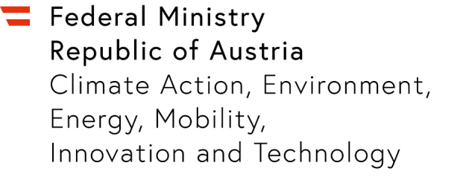

Expression of Interest in an IPCEI Microelectronics II
  - Stage 1
Please complete this template with your project sketch, do not exceed 7 pages (except cover page) (Font: Calibri, size 12 pt margins, single space line pitch).

Company and Contact
Please state the company name, address and contact details

  - Brief introduction of the company and relevant experience

  - Description of the planned project and feasibility of the IPCEI criteria
Please provide an overview of the project content and objectives and explain whether the criteria specified in the call for expression of interest and the FAQ can be met.

  - Goals and Reference to national and European strategies
Please describe the desired goals as well as the reference to national and European strategies such as climate and energy goals, the “Green Deal” and/or the EU digital strategy.

  - Tentative survey of investments
Please provide an overview of the planned costs including investments as well as the financing plan and the amount of the requested state aid.

  - Survey of project-related co-operations
If other companies interested in the IPCEI are already known, these are to be included here with details of the planned form of co-operation.

  - Tentative time plan

  - Reference to the IPCEI
If applicable, please give information on the pan-European IPCEI project in which the specific project is to be embedded.

  - Contact information
Please state the name of the contact person(s) with e-mail address and telephone number.

