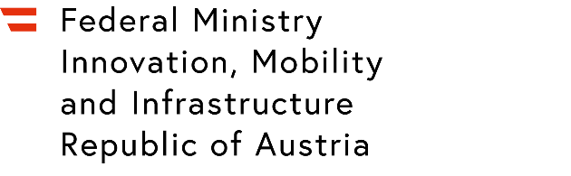

Confirmation by the haulier
Name and Company stamp of the haulier:
Click or tap here to enter text.
According to the implementing regulation (EU) 2021/255, in paragraphs 6.6.1.3., 6.6.1.4. and 6.6.1.5., hauliers transporting air cargo and mail, when security-controls have been applied, are defined as follows:
- The haulier shall ensure that staff collecting, carrying, storing and delivering air cargo and mail to which security controls have been applied undergoes at least the following:
  - a check of the personal integrity, consisting of the verification of the identity and of the curriculum vitae and/or provided references;
  - general security awareness training, in accordance with point 11.2.7.
- Any of the haulier’s staff granted unsupervised access to cargo and mail while performing any of the functions referred to in point 1.), or while implementing any of the security controls set out in this Chapter shall:
  - have successfully completed a background check;
  - undergo security training, in accordance with point 11.2.3.9.
- Where a haulier uses the services of another company to perform one or more of the functions referred to in point 6.6.1.3, such other company shall fulfil the following conditions:
  - sign a haulier agreement with the haulier;
  - refrain from subcontracting further;
  - implement the provisions of points 6.6.1.3 and 6.6.1.4, as applicable.
The haulier subcontracting another transport company retains full responsibility for the entire transport on behalf of the regulated agent.
The names of the personnel who fulfill points 1. and 2. must be announced to the regulated agent before the order is placed.
Other transport companies commissioned by the transport company in charge must be named to the regulated agent before the order is placed.
The regulated agent must be informed by the haulier of any changes as soon as possible.
The haulier must comply with all regulations mentioned, depending on the commissioning of the regulated agent.
The haulier's declaration in accordance with Annex 6-E of DVO (EU) 2015/1998 is, in any case, a prerequisite for the transport of air cargo and air mail, when security-controls have been applied.
The correct implementation of these points is confirmed with your signature.
This conformation is valid for 3 years from the date of signature.
Place and date:
Click or tap here to enter text.
Name and signature of the person responsible or the managing director:
Click or tap here to enter text.

